Supplementary material

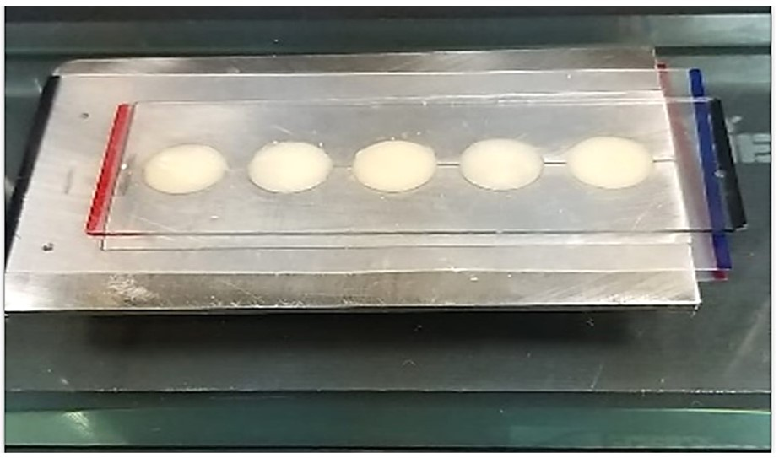
Supplementary Fig. 1. The Plastic Teflon & the Glass slide placed at the Stainless-steel mold with the composite packed.

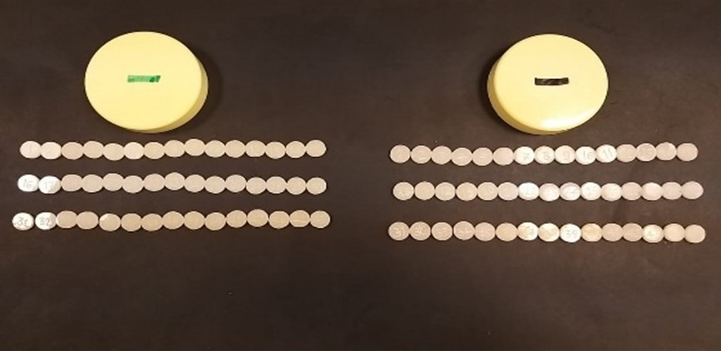
Supplementary Fig. 2. Specimens after polishing and ready for baseline color measurement.

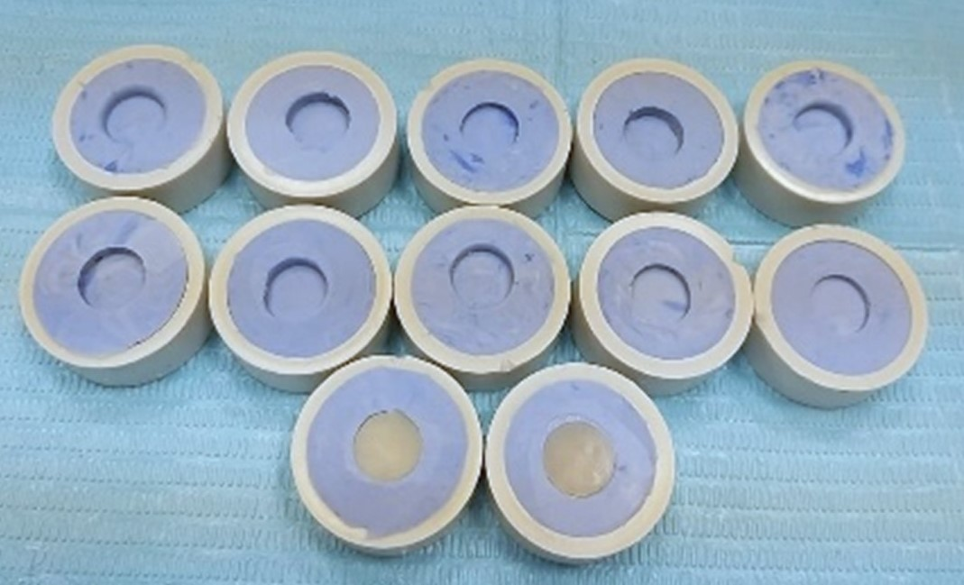
Supplementary Fig. 3. Putty mold used to hold the specimens in place.

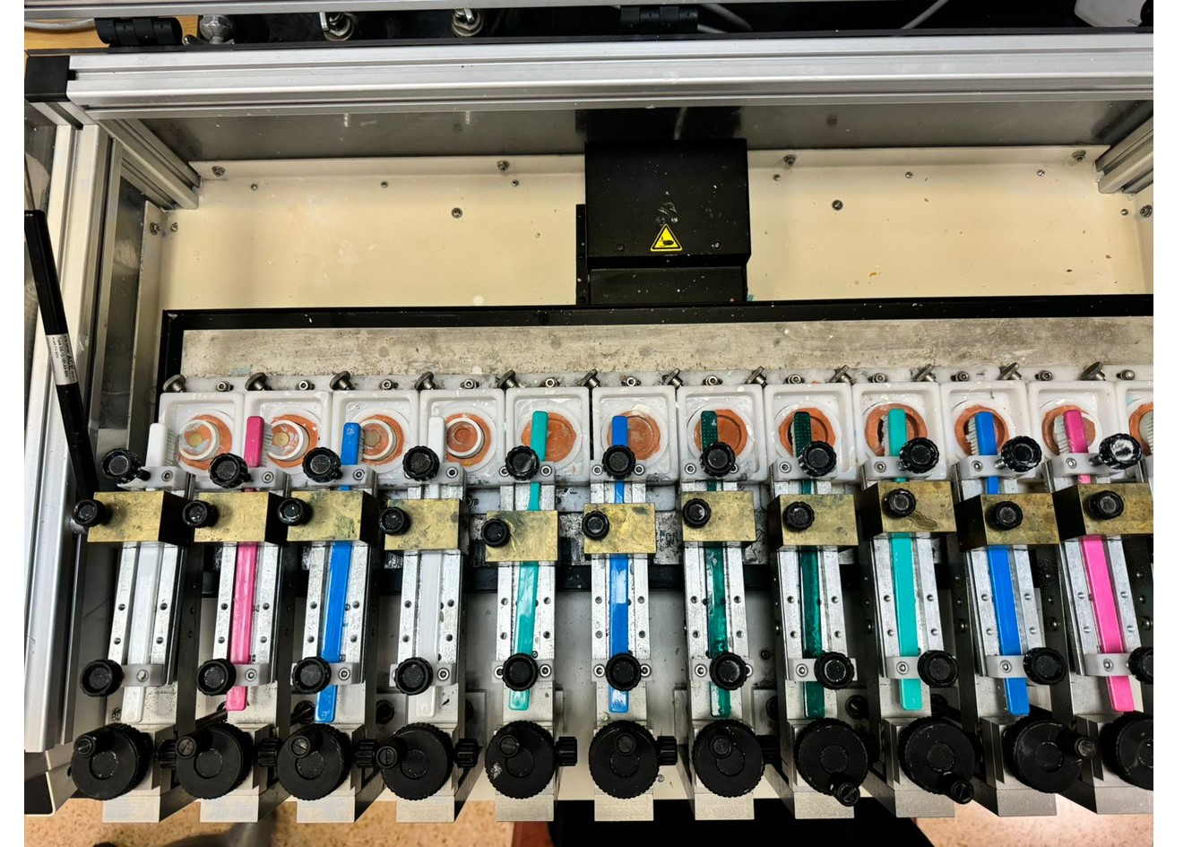
Supplementary Fig. 4. Soft toothbrushes mounted on the toothbrush simulator machine (ZM-3.12, SD Mechatronik GmbH, Germany).

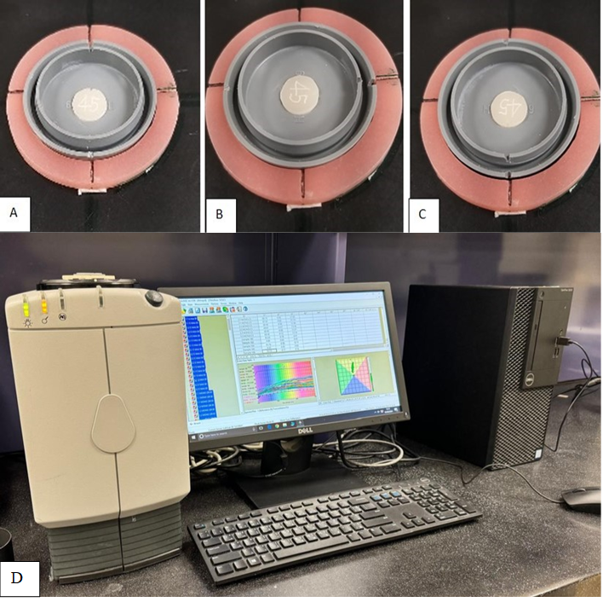
Supplementary Fig. 5. (A) Specimen #45—Scanning in 12 0’clock position, (B) Specimen #45 - Scanning in 12:15 position. (C) Specimen #45—Scanning in 12:30 position, (D) Color coordinate L*, a* and b* measurements of specimen by spectrophotometer.

