Supplementary material

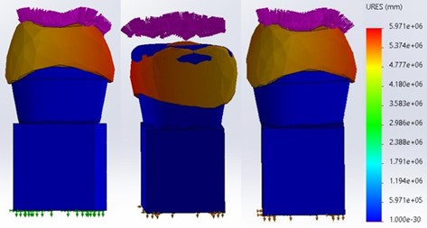
Supplementary Fig. 1. Stress contours on stainless steel, zirconia and BioFlx during perpendicular loading conditions.
Supplementary Fig. 2. Deformation contours on stainless steel, zirconia and BioFlx during perpendicular loading conditions. URES: Static Displacement Plots.

