SUPPLEMENTARY FILES

Excluded Titles | First Author | Year | Journal | Reason for exclusion
Orthognathic treatment with distraction osteogenesis in two asymmetry cases | - Gulsen | 2021 | Gazi Medical Journal | Article not found
Our Hemifacial Microsomia Treatment: The Importance of Both Selecting the Plan for the Grade of Deformity and Orthodontic Management | T. Okumoto | 2003 | Japanese Journal of Plastic and Reconstructive Surgery | Article not found
Treatment modalities for Korean patients with unilateral hemifacial microsomia according to Pruzansky-Kaban types and growth stages. | I. Yang | 2020 | Korean Journal orthodontics | Treatment not described
Effect of early orthopedic intervention on hemifacial microsomia patients: An approach to a cooperative evaluation of treatment results | B. Kahl-Nieke, | 1998 | Am J Ortho Dentofac Orthop. | Treatment not described
Hemimandibular Hypoplasia Successfully Treated with Functional Appliances: Is It Truly Hemifacial Microsomia? | M.C. Meazzini, | 2008 | The Cleft palate-craniofacial journal | Treatment not described
Comparison of Pain Perception in Patients Affected by Cleft and Cranio Facial Anomalies Treated with Traditional Fixed Appliances or Invisalign | M.C. Meazzini, | 2019 | Cleft palate-Craniofacial Journal | Treatment not described
Outcome of surgical-orthodontic treatment in hemifacial microsomia with and without early mandibular distraction osteogenesis. | C. Suppapinyaroj | 2020 | International Journal Oral Maxillofacial Surgery | Article not found
Hemifacial microsomia: extraoral appliance for the early treatment of an infant. Literature review and case report. | L. Gripp | 1997 | Journal Orofacial Orthopedics | Treatment not clearly described
Problems related to jaw distraction treatments and their solutions from the perspective of orthodontists | T. Susami | 2009 | Japanese Journal Plastic Surgery | Treatment not described
Malocclusions and orthodontic management of syndromic patients: A review | A. Sinha | 2019 | Indian Journal of Public Health Research and Development | Treatment not described
Treatment modalities for Korean patients with unilateral hemifacial microsomia according to Pruzansky Kahan types and growth stages | I-H. Yang | ﻿2020 | Korean Journal Orthodontics | Treatment not described
Orthopedic approach to asymmetry | E. Bardinet | 2002 | L' Orthodontie francaise | Article not found
Treacher Collins syndrome - Orthodontic treatment of 11-year-old girl. Case report | M. Andrych | 2005 | Pediatria Polska | Case is not microsomia
Modification of dentofacial growth associated with Goldenhar syndrome | E. Hlaing | ﻿2017 | Acta Medica Okayama | Treatment not described
Combined simultaneous distraction osteogenesis of the maxilla and mandible using a single distraction device in hemifacial microsomia. | H-L. Vu | 2001 | The Journal of craniofacial surgery | Treatment not described
A case of oculo-auriculo-vertebral spectrum with long-term and comprehensive management. | N. Suda | ﻿2006 | World Journal Orthodontics | Article not found
A case of incomplete facial hemiatrophy: Combinated techniques | P. Santanche | 1993 | Rivista Italiana di Chirurgia Plastica | Article not found
Leveling the Maxillary Occlusal Plane Without Orthodontic Appliances in Patients with Hemifacial Microsomia Using Unilateral Vertical Mandibular Distraction Osteogenesis. | N. Pourtaheri | 2020 | Journal Craniofacial Surgery | Treatment not described
Orthodontic elastic traction assisted the Hemifacial Micronesia treatment during activation period of distraction osteogenesis for hemifacial: a multicenter? prospective? cohort study | Molina | 1999 | No | Not found
Orthodontic and maxillofacial confrontation of a hemifacial microsomia, comprising electromyographic check | M-J. Papagrigorakis, | 1989 | Odontostomatol Proodos | Treatment not described
Prediction of difficult airway of the first and second branchial arch syndrome patient by using preoperative cephalometric analysis in orthodontics | S. Tachikawa | 2017 | Journal Japanese Dental Society of Anesthesiology | Not found
Applications of Computer-Aided Design/Manufacturing Technology in Treatment of Hemifacial Microsomia | Y. Sun | 2020 | Journal Craniofacial Surgery | Orthodontic treatment not clearly described
An Interdisciplinary Management of Severe Facial Asymmetry Due to Hemifacial Microsomia | M. Sanjana | 2020 | Contemporary Clinical Dentistry | Adult patient
Bilateral craniofacial microsomia: orthognathic treatment for an advanced dentofacial deformity. | N. Demura | 2013 | Am J Ortho Dentofac Orthop. | Patient with bilateral microsomia and adult
Surgery-first for a patient with mild hemifacial microsomia: A case report and review of literature | J-Y. Song | 2021 | WJCC | Adult patient

Supplementary Table 1. Studies excluded. First author, year, journal and reasons for exclusion.

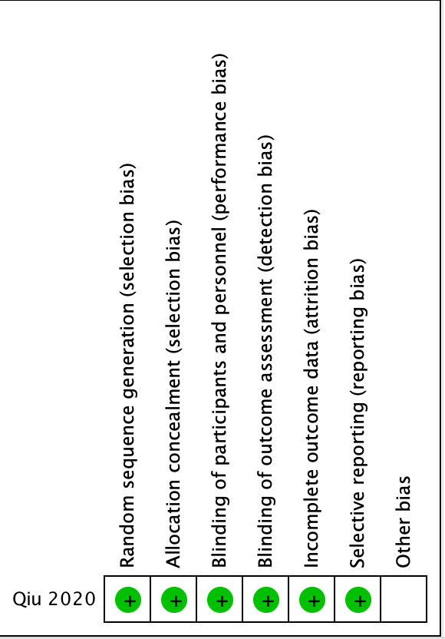
Supplementary Fig. 1. Analysis of the risk of bias by the Cochrane program on analyzed RCT studies qualified as a low risk in all aspects.

